Yeti Wetiasami

Game Design Document

##### Global Game Jam 2015

##### 

*Index*

1. Index
2. Game Design
   1. Summary
   2. Gameplay
   3. Mindset
3. Technical
   1. Screens
   2. Controls
   3. Mechanics
4. Level Design
   1. Themes
      1. Ambience
      2. Objects
         1. Ambient
         2. Interactive
      3. Challenges
   2. Game Flow
5. Development
6. Graphics
   1. Style Attributes
   2. Graphics Needed
7. Sounds/Music
   1. Style Attributes
   2. Sounds Needed
   3. Music Needed
8. Schedule
9. Team

Game Design

## Summary

Kimaro (Old Shaman) and Yeti (Young Amazon) are caught for Portuguese Invaders. Without memories or weapons, they want to get away from the portuguese jail, but everytime they face new challanges.

They discover that only way to get out from fort is solve sonouros puzzles in rooms to unlock doors.

## Gameplay

The goal of the game is freedom. Obstacles are time and Mapinguary, legendary monster of brazilian folklore.

## Mindset

We have two players at same time in game:

Shaman: Kimaro, a slow old man, with weak attack.

Warrior: Yeti, an young amazon, fast and strong, restless and angry.

Obs: You can’t finish this game solo.

Technical

## Screens

1. Title Screen 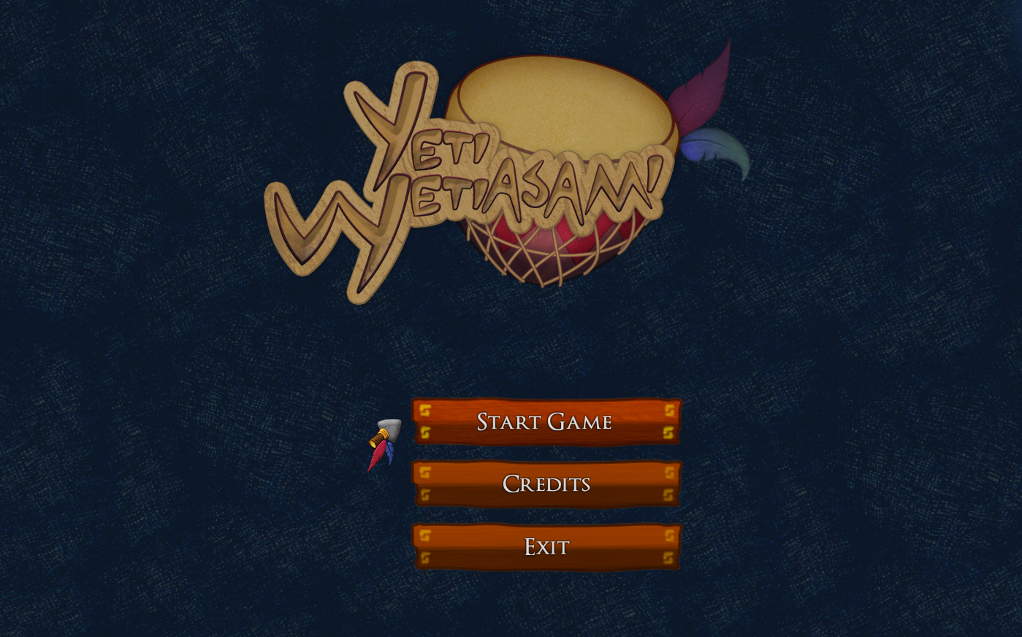
2. Character Select
3. Game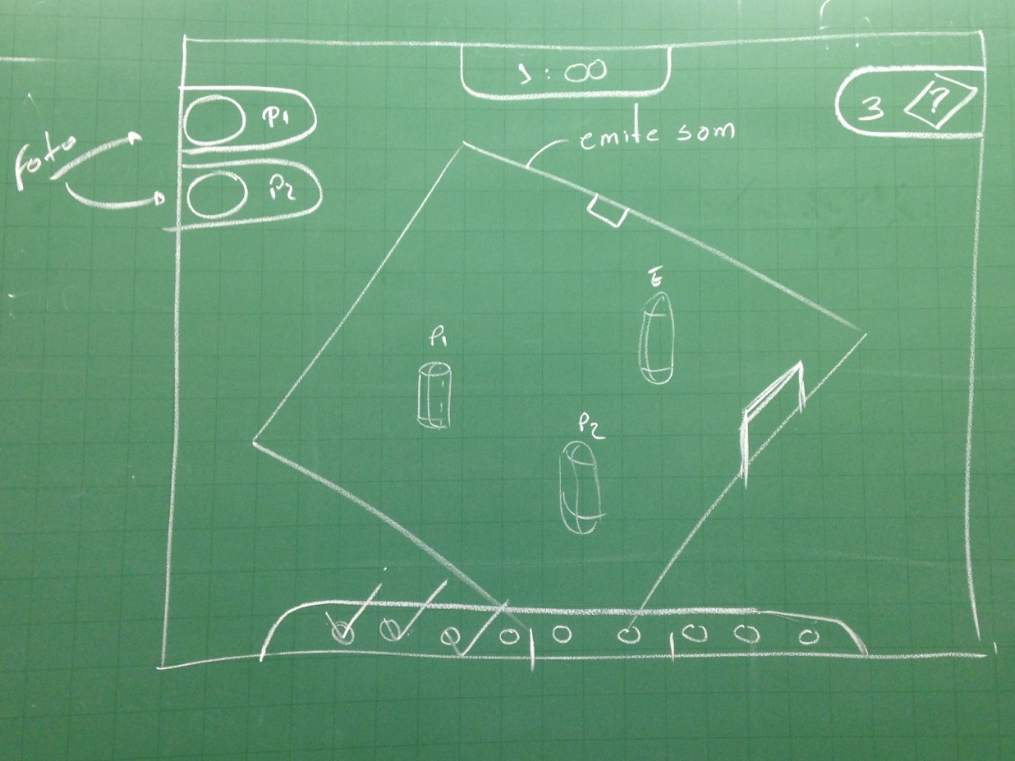
4. End Credits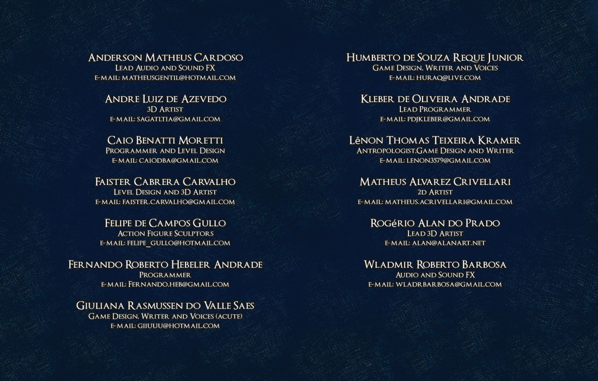

## 

## Controls

Controls will be direction buttons(8-direction) and action button(Interaction).

## Mechanics

The game have a combination of sounds, emitted from specific objects on the screen, which used in one right order give a way to the next phase.

Level Design

## Map

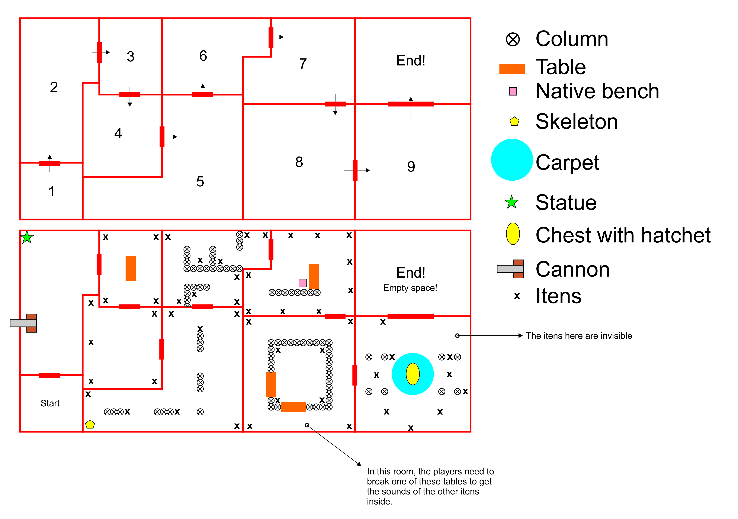

## Game Flow

1. Players start in a jail, inside of the fort.
2. In the second room we have a sequence, the second item is a trigger item, the statue.
3. Here we only have the sequence, but when the player touch the first item, Mapinguary appears.
4. Escape the monster and solve the puzzle.
5. Here we have a skeleton who triggers a part of the narrative.
6. More puzzle.
7. Here we have another item who triggers narrative, the native bench.
8. The puzzle here is: don’t break everything. More sounds puzzles and escape.
9. The final step, here we have 7 invisible itens, the 8th is the chest, who drops na hatchet and the nine item sound comes from the monster’s death. (the chest only drops the hatchet in this order, exactly).

Development

## Players and Enemy

1. BasePlayer
   1. Shaman (Male)
   2. Warrior (Female)
2. BaseEnemy
   1. Mapinguary

## Objects

1. BaseObjects
   1. NoisyItens
      1. Barrel (wood)
      2. Vessel (ceramic)
      3. Bench (wood)
      4. Grid (metal)
      5. Cannon
      6. Chest
      7. Box
      8. Shelf
      9. Table
      10. Column
   2. SilentItens
      1. Skeleton
      2. Picture

Graphics

## Style Attributes

What kinds of colors will you be using? Do you have a limited palette to work with? A post-processed HSV map/image? Consistency is key for immersion.

What kind of graphic style are you going for? Cartoony? Pixel-y? Cute? How, specifically? Solid, thick outlines with flat hues? Non-black outlines with limited tints/shades? Emphasize smooth curvatures over sharp angles? Describe a set of general rules depicting your style here.

Well-designed feedback, both good (e.g. leveling up) and bad (e.g. being hit), are great for teaching the player how to play through trial and error, instead of scripting a lengthy tutorial. What kind of visual feedback are you going to use to let the player know they’re interacting with something? That they *can* interact with something?

## Graphics Needed

1. Characters
   1. Human-like
      1. Goblin (idle, walking, throwing)
      2. Guard (idle, walking, stabbing)
      3. Prisoner (walking, running)
   2. Other
      1. Wolf (idle, walking, running)
      2. Giant Rat (idle, scurrying)
2. Blocks
   1. Dirt
   2. Dirt/Grass
   3. Stone Block
   4. Stone Bricks
   5. Tiled Floor
   6. Weathered Stone Block
   7. Weathered Stone Bricks
3. Ambient
   1. Tall Grass
   2. Rodent (idle, scurrying)
   3. Torch
   4. Armored Suit
   5. Chains (matching Weathered Stone Bricks)
   6. Blood stains (matching Weathered Stone Bricks)
4. Other
   1. Chest
   2. Door (matching Stone Bricks)
   3. Gate
   4. Button (matching Weathered Stone Bricks)

*(example)*

*(Note : If you’re soloing you might not need to define this part, as you can just use the Derived Classes + Themes section as a reference. It’s up to you.)*

Sounds/Music

## Style Attributes

Again, consistency is key. Define that consistency here. What kind of instruments do you want to use in your music? Any particular tempo, key? Influences, genre? Mood?

Stylistically, what kind of sound effects are you looking for? Do you want to exaggerate actions with lengthy, cartoony sounds (e.g. mario’s jump), or use just enough to let the player know something happened (e.g. mega man’s landing)? Going for realism? You can use the music style as a bit of a reference too.  
   
 Remember, auditory feedback should stand out from the music and other sound effects so the player hears it well. Volume, panning, and frequency/pitch are all important aspects to consider in both music *and* sounds - so plan accordingly!

## Sounds Needed

1. Effects
   1. Soft Footsteps (dirt floor)
   2. Sharper Footsteps (stone floor)
   3. Soft Landing (low vertical velocity)
   4. Hard Landing (high vertical velocity)
   5. Glass Breaking
   6. Chest Opening
   7. Door Opening
2. Feedback
   1. Relieved “Ahhhh!” (health)
   2. Shocked “Ooomph!” (attacked)
   3. Happy chime (extra life)
   4. Sad chime (died)

*(example)*

## Music Needed

1. Slow-paced, nerve-racking “forest” track
2. Exciting “castle” track
3. Creepy, slow “dungeon” track
4. Happy ending credits track
5. Rick Astley’s hit #1 single “Never Gonna Give You Up”

*(example)*

*(Note : Again, if you’re soloing you might be able to / want to skip this section. It’s up to you.)*

Schedule

1. Sexta:  
   - 17:00 as 20:00 -> Definição do jogo, roteiro básico e início do GDD
2. Sexta/Sábado  
   - 20:00 as 04:00 -> Estrutura básica do jogo (telas e interface)
3. Sábado  
   - 04:00 as 12:00 -> Mecânica básica  
   - 12:00 as 20:00 -> Conteúdo finalizado (Músicas, artes, modelos)  
   - 20:00 as 23:59 -> Teste de jogabilidade e caça bugs
4. Sábado/Domingo  
   - 00:00 as 12:-00 -> Finalização do jogo
5. Domingo  
   - 12:00 as 15:00 -> Testes Finais  
   - 15:00 as 17:00 -> Apresentação do jogo

Team

- Anderson Matheus Cardoso

Lead Audio and Sound FX

e-mail: matheusgentil@hotmail.com

- Andre Luiz de Azevedo

3D Artist

e-mail: sagatltia@gmail.com

- Caio Benatti Moretti

Programmer and Level Design

e-mail: caiodba@gmail.com

- Faister Cabrera Carvalho

Level Design and 3D Artist

e-mail: faister.carvalho@gmail.com

- Felipe de Campos Gullo

Action Figure Sculptors

e-mail: felipe_gullo@hotmail.com

- Fernando Roberto Hebeler Andrade

Programmer

e-mail: Fernando.heb@gmail.com

- Giuliana Rasmussen do Valle Saes

Game Design, Writer and Voices (acute)

e-mail: giiuuu@hotmail.com

- Humberto de Souza Reque Junior

Game Design, Writer and Voices

e-mail: huraq@live.com

- Kleber de Oliveira Andrade

Lead Programmer

e-mail: pdjkleber@gmail.com

- Lênon Thomas Teixeira Kramer

Antropologist,Game Design and Writer

e-mail: lenon3579@gmail.com

- Rogério Alan do Prado

Lead 3D Artist

e-mail: alan@alanart.net

- Wladmir Roberto Barbosa

Audio and Sound FX

e-mail: wladrbarbosa@gmail.com